DVA218, LAB3a

Leslie Dahlberg (ldg14001), Jonathan Larsson (jln14010)

# Introduction

In this report we discuss how to implement reliable transport protocol build upon the existing UDP-protocol.

# Three-way-handshake

The three-way-handshake will be implemented with SYN and ACK messages send from client to server and back. See figure 1-2 for the state machine diagrams of the client-side and server-side of the handshake. Messages are resent after a timeout. After three unsuccessful resends the action is aborted and state machine returns to its previous state.

# ../State%20Machines/connectionreciever.png

Figure : 3-Way-Handshake (Server)

# ../State%20Machines/connectionsender.png

Figure : 3-Way-Handshake (Client)

# Sliding window

We use the Go-Back-N algorithm for the sliding window protocol. See figures (_) for the state machines. The state machines are simplified in the respect that a infinite sequence of package sequence numbers is assumed.

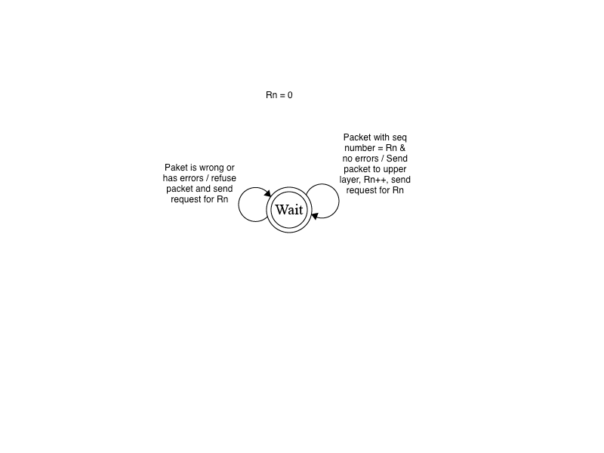

Figure : Sliding window (Server)

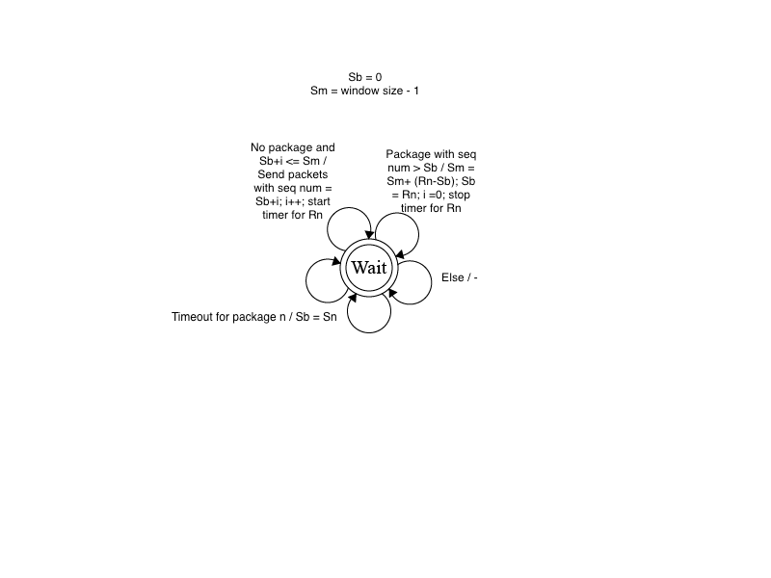

Figure : Sliding window (client)

# Error correction

To check for corrupted packets we will implement the 16-bit internet checksum. The entire package will be divided up into 16-bit numbers and summed and the checksum will be added as the 1-complement to the sum. If the packet contains no errors the summation will return zero on the receiver side.

# Connection teardown

The connection teardown follows a similar process as the three-way-handshake but utilizes FIN messages instead of SYN messages. See figures (_) for the state machines.

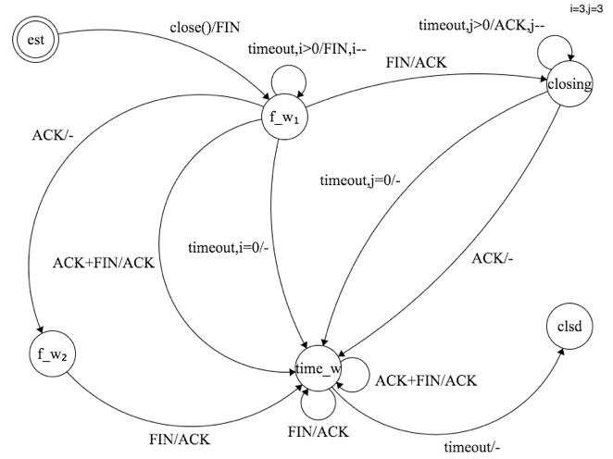

Figure : Connection teardown (Initiator)

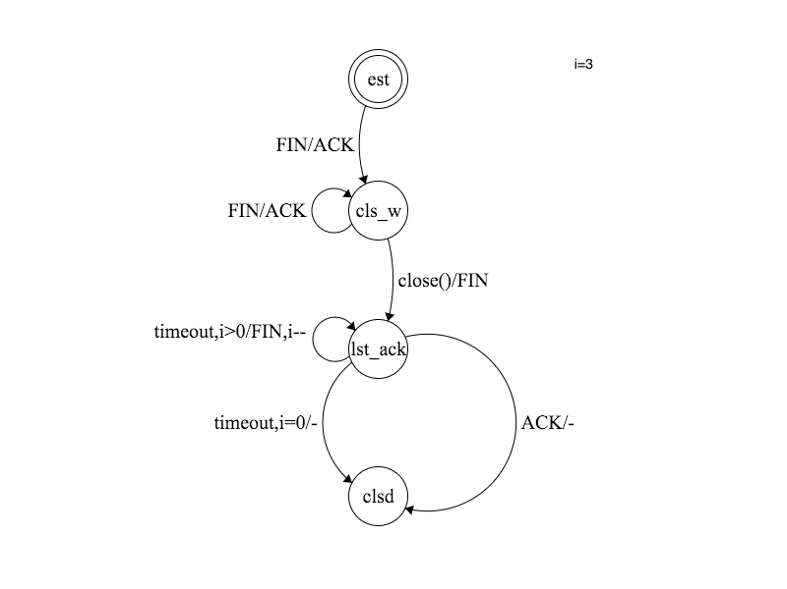

Figure : Connection teardown (Receiver)